Experiment 1
AIM
To execute and study the rm, users, and tree commands in Kali Linux and understand their uses.
ALGORITHM
- Open the Kali Linux Terminal.
- Create a sample file using the touch command.
- Use the rm command to remove the file.
- Use the users command to display the users currently logged into the system.
- Use the tree command to display the directory structure in a tree format.
- Observe and record the output of each command.
COMMANDS AND THEIR USE
Command | Use
rm | Used to remove/delete files.
users | Used to display the users currently logged into the system.
tree | Used to display files and directories in a tree-like structure.
Commands to Execute
1. rm command
touch test.txt
rm test.txt
Use: Deletes test.txt.
2. users command
users
Use: Shows the users currently logged into Kali Linux.
3. tree command
tree
Use: Displays the current directory and its files/folders in tree format.
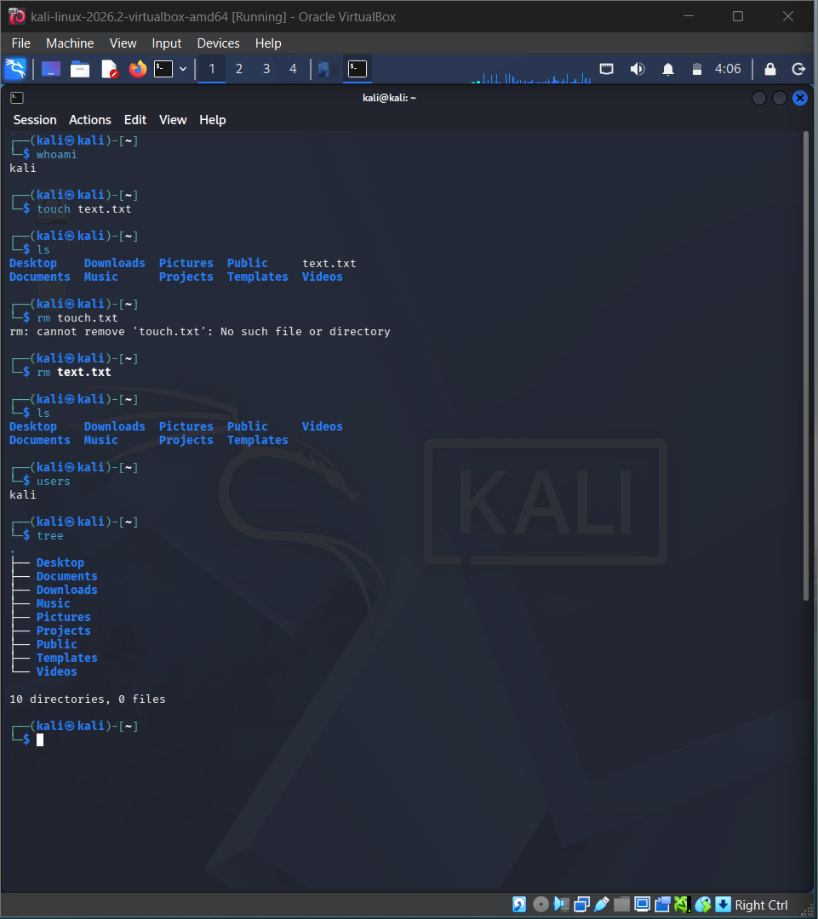
RESULT
Thus, the rm, users, and tree commands were successfully executed in Kali Linux and their uses were studied.

